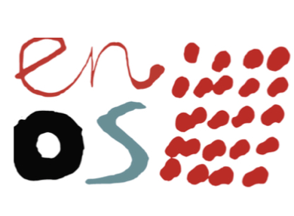
East Neuk Open Studio
Renewal of & New Membership 2023 - 20th Anniversary of ENOS
Open Studios – 24th/25th June & 1st/2nd July 2023
November Art and Craft Market (Bowhouse tbc)
You must have a permanent address in the East Neuk to qualify for this group.
You must also be the creator of your own hand-made art or craftwork,
or your own design on a manufactured product.
Name
Name of business
Address
Email address
Phone
Website
Social media links
Type of art work
A very short text about yourself and your work for the brochure:
(you may submit a longer one for the website)

Please send a minimum of 4 clear high resolution images of your work, for the website and for publicity to Dave at: design@eastneukopenstudios.org
A proof copy of the brochure publication will be sent to each member for checking before going to print.
Send a payment of £90 membership fee for 2023 this covers two weekend exhibitions in June/July and on-line representation. There will be an additional charge for the November event, subject to Bowhouse costs. (TBC)
We may also be holding a special Anniversary Exhibition at Easter 2022. (TBC)
Please note there will be no Half fees available this year.
Please pay by BACS: ENOS a/c 00231951 sort code 83-15-21
If you are not able to do this, please send a cheque made payable to ENOS to our treasurer: Lavinia Kilbribe 13, Crail Road, Anstruther, Fife, KY10 3EL
Please save and return this completed form by email to: membership@eastneukopenstudios.org or deliver to Susan McMillan, 67 Main Street, Lower Largo, Fife, KY8 6BN
PLEASE SEND A COPY OF YOUR INSURANCE DOCUMENT WITH THIS APPLICATION.
PLEASE USE THIS CHECKLIST TO MAKE SURE YOU HAVE COMPLETED ALL REQUIREMENTS Please sign below
With my signature I agree to share the information and images I have given to ENOS with other ENOS members and the public.
I agree to ENOS holding the information given
I have paid my subscription by BACS / Cheque – (please circle) of £90
I intend to exhibit in June/July 2023.
I intend to exhibit at the Christmas Craft and Art Market 2023
I have provided proof of my insurance documents

Please note: all the above information will be made public unless you indicate otherwise.

